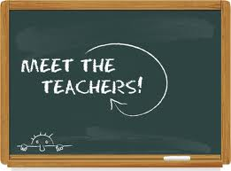
Agenda for this evening:

- Introductions and what we teach!

- Discuss school goal of building resilience.
  - Classroom set-up - Grade 6
  - Field trips - Camp Evergreen, Alford Lake, Alberta Legislature
  - Safety Patrol
  - School jobs
  - School Clubs - Run Club, Intramurals, “We” Club

Peer Collaboration
Improvement-Focused Learning
Responsibility
Active Learning
Twenty-First Century Skills
Empowerment

- REMIND - sign up and why
  - Mr. Swain’s
  - Grade 6 and 7 classes

- Class Website
  - Purpose
  - Navigating - what is on here?
  - Student role

- Bears Athletics
  - cross country
  - volleyball
  - basketball
  - track

- Division Software Changes and the future

